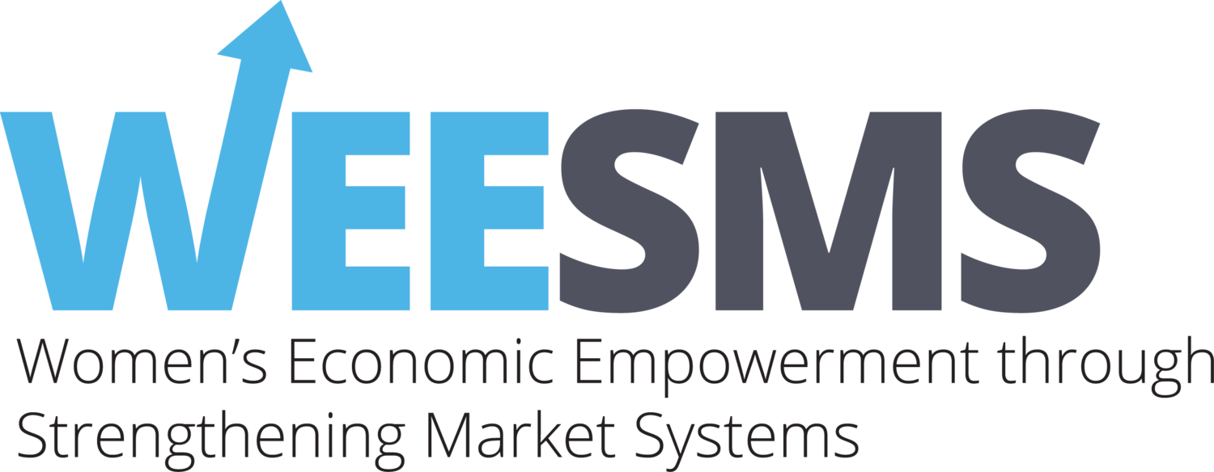
WEESMS | Classification of SMEs Based on Tiers
The definitions of Small Medium Enterprises (SMEs) often vary by country and are usually based on the annual turnover or the value of the assets and the number of employees. The WEESMS programme follows the guidelines and the definitions of Cottage, Micro, Small and Medium Enterprise (CMSME) set by the Ministry of Industry, under the National Industrial Policy of 2016.
In addition, the programme has also created a Tiering system for the SMEs in order to deliver our interventions effectively based on the needs of each of these tiers.

The following criteria have been established in the programme to segregate SMEs in different tiers based on the physical evidence and performance indicators:

S.N. | Description | Tier A | Tier B | Tier C | Tier D
1. | TIN Certificate of Business | Yes | NA | NA | NA
2. | Trade License (Updated) | Yes | Yes | Yes | NA
3. | Separate Manufacturing unit | Yes | NA | NA | NA
4. | Current Bank Account in the name of Business | Yes | Yes | NA | NA
5. | Laptop/Desktop for Business Usages | Yes | NA | NA | NA
6. | Smartphone for Business Usages | Yes | Yes | Yes | NA
7. | Bookkeeping and Business management | Yes | NA | NA | NA
8. | Quarterly Sales volume | 5 lakh+ | 3-5 lakh | 1-3 lakh | less than 1 lakh
9. | Monthly Production Capacity  (For major 3 products) | >500 | 301-500 | 101-300 | <100
Number of SME in Rangpur Zone[N=280] |  | 23 | 57 | 81 | 119
Percentage of SME in Rangpur Zone |  | 8.2% | 20.4% | 29% | 42.4%
Number of SME in Khulna Zone[N=273] |  | 13 | 36 | 43 | 181
Percentage of SME in Khulna Zone |  | 5% | 13% | 16% | 66 %

Based on the cluster needs assessment conducted in 2019, WEESMS has identified different groups/tiers of SMEs who have disparate needs among the groups/tiers but are homogenized within. The interventions have hence been designed in a process that takes into account these unique needs of the SMEs.
For capacity building and information dissemination support on various areas including product design, e-commerce management, and also gender sensitization and decent work practices, higher tier SMEs will be upskilled directly through programme interventions and activities, which they will then impart to lower-tier SMEs who will be their cluster members. For market linkage support which includes different financial products, business registration support, Business to Business (B2B) markets, etc., different tiers of SMEs will be connected to specific service providers who will cater to their specific requirements. The ultimate objective is to ensure Tier A SMEs experience unbridled business growth, while Tier B, C and D SMEs graduate to respective upper levels by year-end.
Tier A SMEs: Tier A SMEs are the ones which fulfil the criterion for all of the physical evidence requirements ( Indicators 1 through 7), but also are on the highest threshold for the performance-based indicators (indicators 8 through 9). They are the biggest SMEs within the project beneficiary groups with separate production units, and larger workforce for both production units and home-based. The following support can be delivered to this tier of SMEs:
Activity Focus for Tier A SMEs
- INT 2: Workplace safety measurement and decent workplace
- INT 4: Manufacturing reengineering support for their signature product/s to increase efficiency
- INT 4 & 7: Cluster Leader: Endowing them with cluster leadership (Bagdoom agent, master trainers, etc.)
- INT 5: Access to finance-large scale: As they have all documents to avail it
- INT 7: Access to B2B market: As they produce in bulk
- INT 7: Access to B2C market: Online (Bagdoom, others) & offline (national fair & others)
- INT 7: Access to Export Markets: As they have few linkages on this regard but have capacity.
- INT 7: Priority to attend international and national level fairs

Tier B SMEs: The SMEs in the second tier fulfill physical evidence criteria including having a separate business bank account, updated trade license and smartphone for business usage. These are mostly home-based SMEs who do not have separate production centers. Most of their production efforts are focused on small scale over a diverse array of products. Thus, they cannot achieve the economies of scale required to cater to wholesale, B2B markets with competitive prices. Only a select few of them produce one or two specialized/signature products at large scale, with which they are able to enter the B2B market. The following support can be delivered to this tier of SMEs:
Activity Focus for Tier B SMEs
- INT 1: Support for Financial Management
- INT 2: Workplace safety measurement and decent workplace
- INT 1, 4, 5 & 7: Capacity development support for moving to Tier A
- INT 4: Manufacturing reengineering for their signature product/s or services to increase efficiency that will make them ready to sell their products in the B2B Market.
- INT 5: Access to finance-small scale: As they have most of the essential documents to avail it
- INT 7: Access to B2C market: Online (Bagdoom, others) & offline (regional fair & others)
- INT 7: Access to B2B market: Only for those SMEs who are capable (but very few)
- INT 7: Priority to get regional level fair participation

Tier C SMEs: This is the third tier of the SMEs who are currently in the growth stage of their business. They have at least an updated trade license and smartphone for their business. This tier comprises new SMEs onboarded (cohort 2) along with previous cohort SMEs who are lacking in performance indicators. As there is significant room for growth for these SMEs, they will be groomed as specialists in offering certain products and services. This tier mostly gets subcontracted orders from Tiers A & B and supplies to them directly. Following support can delivered to this tier of SME:
Activity Focus for Tier C SMEs
- INT 1: Support for Financial Management
- INT 1, 4, 5 & 7: Capacity development support for moving to Tier B
- INT 4: Manufacturing reengineering for their signature product/s or services to increase efficiency that will make them ready to sell their product in the B2B Market
- INT 7: Access to B2C market: Online (Bagdoom, others) & offline (regional fair & others)
- INT 7: Access to B2B market: Through subcontracted orders from Tier A & B
- INT 7: Priority to get local level fairs [District]

Tier D SMEs:
This is the fourth tier of SMEs who have only one or less of the six physical evidences. Similar to Tier C, this includes new SMEs onboarded (cohort 2) along with previous cohort SMEs who are lacking in performance indicators. However, they have either not formalized their business by availing a trade license, or have done so before, but their trade licenses have currently expired. Therefore, the support should mostly focus on the graduation of these SMEs to the upper level, tier C - which includes the mandatory formalization of their business through acquisition of trade license and other business registration documents. This tier mostly gets subcontracted orders from Tiers A & B and supplies to them directly. The following support can be delivered to this tier of SME: -
Activity Focus for Tier D SMEs
- INT 1: Support for Financial Management
- INT 1, 4, 5 & 7: Capacity development support for moving to Tier C
- INT 4: Manufacturing reengineering for their signature product/s or services to increase efficiency that will make them ready to sell their product in the B2B Markets
- INT 7: Access to B2C market: Online (Bagdoom, others) & offline (regional Fair & others)
- INT 7: Access to the B2B market: Through subcontracted orders from Tier A & B
- INT 7: Priority to get local level fair [Upazila]

